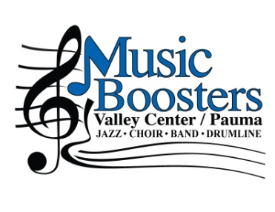
Membership Application
2018-2019

Music Boosters supplements the district’s music budget and helps to provide instruments, transportation, and materials for students in the Valley Center/Pauma Unified School District
General Membership $10 ______

Silver Level $25 ______
♦ All membership levels are entered into a drawing to win 4 amusement park tickets ♦

Gold Level $50 ______

Corporate Sponsor – Advertisement in all community concert programs (Veteran’s Day, Christmas, Jazz Benefit), respectively (whole page, half page, quarter page, eighth page)

$1,000+ Whole Note ______ $250 Quarter Note ______
$ 500 Half Note ______ $150 Eighth Note ______

Name(s):
Please make your check payable to Valley Center/Pauma Music Boosters (VCPMB)

Return to your child’s teacher or mail to:
PO Box 841, Valley Center, CA 92082

Thank you for your support!
Tax ID #08086831, a 501c3 charitable organization supporting music in our schools

Music Family Information (This information is for use only by VCPMB, and will not be released to any third parties.)

Parent(s)/Guardian(s)/Business Name: ___________________________________________________________

Address: _____________________________________________________________________________________

Best Way to Contact: Email _________________________ Phone: _______________ Cell: _________________

Student Name: ___________________________________ School: ___________________________________________
Grade: _____________ Music Group: ____________________________________________________________

Student Name: ___________________________________ School: ________________________________________
Grade: _____________ Music Group: _____________________________________________________________

Groups include:
Elementary Schools – Beginning Band at Pauma, Lilac and VC Elementary
Middle School - Choir, Beginning Band, Intermediate Band, Advanced Band, Drum Line & Jazz Band
High School - Choir, Concert Band, Jazz Band, Marching Band, Drum Line, Color Guard & Winterguard

